**Highfield Middle School - Year 7 Geography**

To access Kerboodle, you will firstly need to go to kerboodle.com -

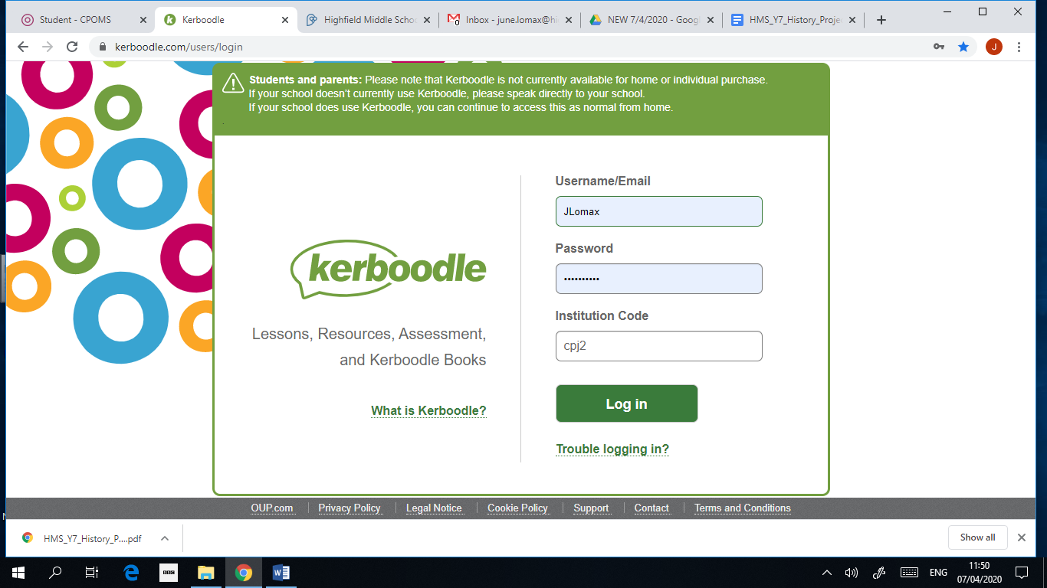

Your username will usually be the first letter of your first name, followed by your surname (with no capitals or spaces) e.g. John Brown’s username would be – jbrown

If this is the first time you are logging on, your password will be exactly the same as your username until you change it (if it isn’t, you must have logged in and changed it previously).

As you can see, our institution code is – cpj2

* if you have problems logging in, email Miss Lomax @ june.lomax@highfield.northumberland.sch.uk

Once you have logged in, you will need to click on Geography AQA. You will then be able to see the digital book and any assignments you have been given for the unit you are working on– ... happy kerboodling!

Miss Lomax