How to survive on a desert island

Paul Hart, a former Royal Navy lieutenant commander, offers advice on how to survive should you find yourself stranded on a desert island, including tips on finding food and building a shelter

|  |  |  |  |  |  |  |  |  |  |  |  |  |  |  |  |  |  |  |  |  |  |  |  |  |  |  |  |  |  |  |  |  |  |  |  |  |  |  |  |
| --- | --- | --- | --- | --- | --- | --- | --- | --- | --- | --- | --- | --- | --- | --- | --- | --- | --- | --- | --- | --- | --- | --- | --- | --- | --- | --- | --- | --- | --- | --- | --- | --- | --- | --- | --- | --- | --- | --- | --- |
| |  |  |  |  |  |  | | --- | --- | --- | --- | --- | --- | | |  |  |  |  | | --- | --- | --- | --- | |  |  |  |  | | 0 | | |  |  |  |  |  |  | | --- | --- | --- | --- | --- | --- | | |  |  |  |  | | --- | --- | --- | --- | |  |  |  |  | | 0 | | |  |  |  |  |  |  | | --- | --- | --- | --- | --- | --- | | |  |  |  |  | | --- | --- | --- | --- | |  |  |  |  | | 0 | | |  |  |  |  |  |  | | --- | --- | --- | --- | --- | --- | | |  |  |  |  | | --- | --- | --- | --- | |  |  |  |  | | 0 | | |  |  |  |  |  |  | | --- | --- | --- | --- | --- | --- | | |  |  |  |  | | --- | --- | --- | --- | |  |  |  |  | | 0 | | |  |  |  |  | | --- | --- | --- | --- | |  |  | l |  | |

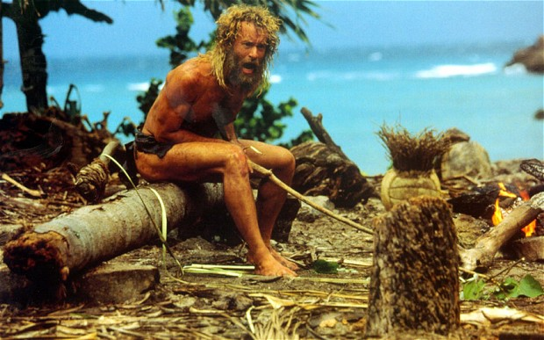

Tom Hanks in the 2000 film Cast Away Photo: REX FEATURES

By Paul Hart

5:26PM GMT 31 Jan 2014

Spending time lying on a palm-fringed beach, with tropical blue waters lapping at your feet might seem like the perfect holiday! But what if there was no umbrella to keep the sun off your head, no waiter to bring you a frosted glass of beer and no hotel to retreat to in the evening for a welcome shower and hot meal? It wouldn’t be long before that desert island paradise became your worst nightmare.

Being shipwrecked or crash-landing on an uninhabited desert island might seem like a scary proposition, but in reality your chances of survival are pretty high as long as you follow a few simple procedures and keep things in perspective. A desert island might have its own challenges but being close to the sea, having natural warmth and an abundant supply of food will all contribute to making your survival more likely than if you had found yourself washed up on an uninhabited polar coastline.

The first thing to remember, if you find yourself alone and in a survival situation, is that a positive and optimistic frame of mind can be the difference between life and death. There are many examples where people with no survival experience have managed to remain alive for extremely long periods before being rescued. Their adaptability, calmness and clear thinking have all been instrumental in helping them get through the ordeal. However, it was that positive mental attitude that meant they battled on where others would have succumbed to despair and given up the routines necessary to sustain life.

If you do find yourself in such a predicament, here are a few tips to keep in mind in order to not just survive, but also thrive and be able to greet your rescuers with a smile and a full belly.

**Avoid injury**

Once you have removed yourself from any immediate danger, the first thing to do is make sure you deal with any injury you may have sustained as quickly as possible. In addition, you have to make sure you avoid sustaining any further injury, no matter how minor, as long as your desert island ordeal lasts. In the tropics, any cut can quickly go septic and result in gangrene, so it is essential to avoid and treat injuries effectively.

I used to run an exercise that tested participants on what piece of equipment they would choose first if their boat was wrecked on a coral reef, near a desert island. Invariably, they would choose water or something to start a fire. The correct answer was a pair of wellies, so that they could wade ashore without getting cut on the coral. Just as bad on such coasts are 'cone shells', which shoot out poisonous barbs - some of which can kill an adult. Once ashore, the wellies have the added advantage of being able to store water, though the taste of stale feet can take a while to get used to.

**Salvage all you can**

If your boat or plane has broken up, it is a source of many of the items you will need to aid your survival. Anything can be adapted for use in an alternative context. Items can be used to build shelter, beds, make clothes and footwear. It is down to your ingenuity and creativeness as to how you can make things work in your particular circumstance. One of the key things to think about is how items can be adapted to create tools that you need. A knife is a really crucial item that will allow your life to move from one of merely survival to being able to thrive. Axes and hammers all become essential when you need to build something that will make your life more bearable.

**Obtain a source of water**

Water is crucial to life. After only a few days without water you will die. Only a couple of hours without water in a hot climate will drastically reduce your ability to think and operate effectively. Fortunately, desert islands tend to be gifted with plenty of fresh water. If your island has plenty of vegetation such as palms or coconut trees then there will be water. If the island is a flat barren piece of sand, then that optimistic frame of mind I told you about might seem a little misplaced. However, even if there is nothing more than sand, you have the option to use the sea as a source of water. Obviously, drinking seawater will kill you, but, if you have even a few items from your broken plane or boat then you can make a “solar-still,” which will allow you to turn salt-water into distilled water

Small streams running into the sea are better than big ones as they will carry less silt. Caves can often have water dripping down inside them so those wellies can come in handy while you put your feet up on the beach. Thunderstorms will provide a lot of water so having plenty of things to collect water in will make life much easier.

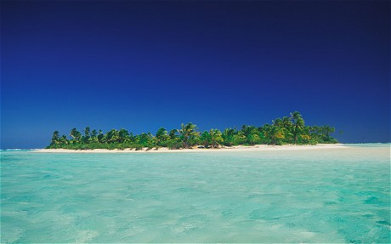

**Build a shelter**

Having a shelter is essential. It might not seem probable, but it is easy to go down with hypothermia if you are on a desert island where there are lots of evening thunderstorms. As the sun sets, the clouds will unleash the huge amounts of water that have been evaporated by the heat of the day. This water will be freezing so if you are out in it then it will chill you to the bone.

It is also important to try to sleep off the ground. In tropical regions, you will commonly encounter snakes, which may be poisonous. A fire, and a clearing around your shelter, will help you avoid coming into contact with them. Snakes will generally avoid you as much as you would want to avoid them (although they can be a great source of food if you can make the right traps).

Your shelter should also reduce the amount of insect bites you sustain, but if you can make any kind of mosquito net from your materials this will aid your survival. First, build your outer shelter from whatever resources you can find. Then crawl underneath some material such as a sheet, suspended from a central point and flaring out like a wigwam, to avoid being constantly bitten. Remember to build your shelter away from any coconut trees: you don't want a coconut falling 50 feet on to your head!

**Find food**

There will generally be plenty of food available if you end up trapped on a desert island. Molluscs, oysters, clams, mussels, seaweed and fish can all be eaten, though some care is needed to make sure they are not poisonous, which they can be in certain conditions and at certain times. If they are hard to dislodge or open, then they are generally ok to eat. If they come off easily or open easily then it most likely means they are diseased, so avoid.

Where possible always cook your food, particularly shell fish, so that parasites are killed and any poisons denatured. Watch out for fish that have poisonous barbs. Sea snakes are normally extremely venomous.

Use what you have salvaged to create a hook and at low tide look for worms to use as bait. If you find a pool that fills with the incoming tide, then you can trap fish when the tide recedes. Away from the beach, you may find other opportunities to find fruit and vegetables.

It is important to conduct tests where possible to establish if what you are eating is poisonous. Start by rubbing the food over the back of your hand and wait for several minutes to see if there is any kind of reaction. If nothing occurs, try the item against your upper lip very carefully and again wait to see if there is a reaction. If nothing happens, then try the item gingerly against your tongue and see if this creates a reaction. The penultimate step is to put a morsel in your mouth and hold it there for a while before taking it out again. If nothing happens, then try a bit. If you die then that is really unlucky, but the far greater chance is that the food is ok to eat.

There are many more ways to make survival a reality if you find yourself trapped on a desert island. If you can somehow make sure you have your iPhone, a solar-charger and the SAS Survival App installed on the phone, then your chances of survival will improve massively. But if you don’t, then just having a modicum of common sense, being adaptable and above all keeping your mind focused and positive, will give you a real chance of being rescued.

***Paul Hart spent four years living in Borneo and has lived and worked in the Jungles of Belize***

