

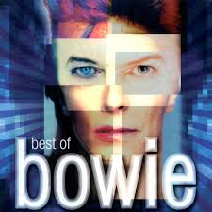

**Art Transition Project 2020**

**PORTRAITS**

**The starting point for this piece of work is an album cover from The Best of Bowie. This picture uses the face of David Bowie as a starting point and then adds boxes on top of each facial feature to add interest.**

**Your task is to create a portrait artwork in any style or size that you choose. It can be a self-portrait, a portrait of somebody known, or a random face.**

**Your work should show:**

**PART 1: A detailed outline drawing of a face that is in proportion with the features correctly placed. The drawing should show outlining and shading.**

**PART 2: The work should then show other skills- paint, pastel, collage, watercolour, pen work, pattern etc.**

